The war of virtual world
Time Limit: 1000 mSec Memory Limit : 32768 KB
Problem Description
The war of virtual world will fight again. In order to prepare better for the war, the federal headquarters decided to conduct a military exercise. Commander AC as Red while yayamao play the Blues!
The rules of the exercise is very special. There are N different laser emission point(we ensure that does not exist any three points are collinear).First AC arbitrarily select two different laser emission points a, b and connect them, then yayamao select two different points from the n-2 laser emission points and connect them.
AC has n(n-1)/2 kinds of options to select a, b. For the i-th selection, assume yayamao has Ki kinds of options to select c, d to make ab and cd intersect.
In order to know the exercise is successful or not, the headquarters defines the value of exercise evaluation formuka:
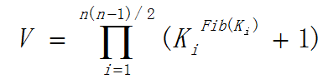
Fib(0) = Fib(1) = 1
Fib(n) = Fib(n-1)+Fib(n-2)

Input
There are multiple test cases.
For each case, the first line contains an integer n (n <= 200) indicating the number of the points.
Followed n line, each line two integer xi, yi.(-100,000<=xi,yi<=100,000)
Output
Output an integer v indicating the value mod 1,000,000,007.
Sample Input
4
0 0
0 1
1 0
1 1
Sample Output
4

